Cloud Fundamentals

Cloud computing is a means by which computational power, storage, collaboration infrastructure, business processes and applications can be delivered as a utility. You only pay for what you use.

**Service-Oriented Architecture (SOA)**

It utilizes the principle of service orientation to organize the overall technology architecture of an enterprise. It means that technology is selected and integrated to support an architectural model that is specified as a set of services.

**Hardware Virtualization**

It is the abstraction of computing resources from the software that uses cloud resources. It involves embedding virtual machine software into the server’s hardware components. That software is called **Hypervisor**. It is also known as Virtual Machine Monitor (VMM).

**Hypervisor’s** role is to provide a means by which virtual machines can access and communicate with the hardware layer, without installing an operating system. The primary task of any hypervisor is to process monitoring, memory and hardware controlling. On top of the hypervisor. **Virtual machines (VM)** are installed. Each VM appears to function as a discrete computational resource, even though it does not physically exist. A host **operating system** is installed upon each VM, thus enabling traditional computing applications to be built on top of the OS.

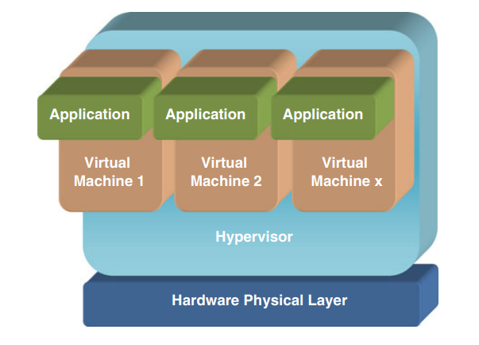

Advantages of Hardware Virtualization:

1. **Lower Cost:** Multiple OS can exist together in a single hardware. This minimizes the quantity of rack space, reduces the number of servers, and eventually drops the power consumption.
2. **Efficient resource utilization:** Physical resources can be shared among virtual machines.
3. **Increase IT flexibility:** The quick development of hardware resources became possible using virtualization, and the resources can be managed consistently also.
4. **Advanced Hardware Virtualization features:** With the advancement of modern hypervisors, highly complex operations maximize the abstraction of hardware & ensure maximum uptime. This technique helps to migrate an ongoing virtual machine from one host to another dynamically.

**Autonomic Computing**

As computing technology becomes more complex, there is a corresponding desire to delegate as much management as possible to automated systems. Autonomic computing attempts to specify behaviors that enable the self-management of systems. **Self-CHOP (Self-Configuration, Self-Healing, Self-Optimizing, Self-Protection)** is a principle defined by IBM autonomic computing initiative.

**Proper Definition of Cloud Computing**

Cloud computing is a model for enabling ubiquitous, convenient, on-demand network access to a shared pool of configurable computing resources (e.g. networks, servers, storage, applications, and services) that can be rapidly provisioned and released with minimal management effort or service provider interaction.

This cloud model is composed of 5 essential characteristics:

1. **On-demand self-service:** The time lag between request and actual availability meant that resource increases had to be planned for and could not be depended upon as a reactive resource. Cloud computing should incorporate enough agility and autonomy, that requests for more resource are automatically and dynamically provisioned in real time, without human intervention.
2. **Broad network access:** The resources must be available over the internet using established mechanisms and standard protocols. Any type of device should be able to access those resources.
3. **Resource Pooling:** The virtualized layer enables the resources of a cloud computing provider to be pooled together into one large virtual resource, enabling large-scale efficiencies to be achieved by the dynamic management of hardware and virtualized resources. This results in the appearance of homogeneous resources to the consumer, without indicating the physical location or granularity of that resource.
4. **Rapid Elasticity:** Requests for extra resource are self-managed and automatic in relation to demand. From the consumer’s perspective, the supply of compute resources is limitless.
5. **Measured Service:** Cloud computing resource providers dynamically optimize the underlying infrastructure and provide a transparent metering service at a level of abstraction that is relevant to the consumer.

The characteristics above are reliant upon a fundamental architecture of hardware resources that are discrete and varied, upon which there is an abstraction layer of software that realizes the characteristics of cloud computing. The physical hardware resource layer includes processor, storage and networking components, and the abstraction layer consists of at least a self-managed virtualization infrastructure.

**Cloud Computing Service Models**

There are 3 types of service models.

1. **IaaS (Infrastructure as a Service):** Lowest level service available to a cloud computing consumer and provides controlled access to a virtual infrastructure upon which operating systems and application software can be deployed. This can be seen as a natural extension of an existing hardware provision, without the hassle and expense of buying and managing the hardware.
2. **PaaS (Platform as a Service):** This sits atop IaaS. This layer is ready for applications to be deployed, as the necessary operating system and platform-related tools such as language compilers are already installed and managed by the cloud computing provider. Consumers may be able to extend the existing tool set by installing their own tools, but absolute control of the infrastructure is still retained by the provider. Thus, the consumer has control over application development, deployment and configuration, withing the confines of the hosted environment.
3. **SaaS (Software as a Service):** This service model abstracts the consumer away from any infrastructure or platform level detail by concentrating upon the application level. Applications are available via thin client interfaces such as internet browsers or program interfaces such as mobile phone apps. Google’s Gmail is one example of cloud computing application. An organization can adopt Gmail and never concern itself with hardware maintenance, uptime, security patching or even infrastructure management. The consumer can control parameters within the software to configure specific aspects, but such interventions are managed through the interface of the application. The end user gets an email service and does not worry as to how it is provided.

**Cloud Computing Deployment Models**

**Public Cloud:** available to the general public and is managed by an organization. The cloud computing provider owns and manages the cloud infrastructure. For ex. Google.

**Private Cloud:** It has an exclusive purpose for an organization. The cloud resources may be located on or off premise and could be owned and managed by the consuming organization or a third party. An organization may also wish to extend its current IT capability by using an exclusive, private cloud that is remotely accessible and provisioned by a third party. Such an organization may feel uncomfortable with their data being held alongside a potential competitor’s data in the **multi-tenancy model** (existence of many different consumers withing one cloud architecture).

**Community Clouds:** It is a model of cloud computing where the resources exist for several parties who have a shared interest or cause. This is very similar to the single-purpose grids that collaborating research and academic organizations have created to conduct large-scale scientific experiments (e-science). The cloud is owned and managed by one or more of the collaborators in the community, and it may exist on or off premise.

**Hybrid Clouds:** It is formed when more than one type of cloud infrastructure is utilized for a situation. For instance, an organization may utilize a public cloud for some aspect of its business, yet also have a private cloud on premise for data that is sensitive.